|  |  |
| --- | --- |
| EGC_Black | **Eastern Goldfields College**  Mathematics Essentials 2017  Application 31 |
|  | Time allowed: 60 minutes Task Weighting: 8% |

**Investigation – Probability and Simulations**

Name: Mark: /43

* **One A4 page of notes and scientific calculator allowed.**
* **Working is required for full marks for any question worth more than one mark.**

\_\_\_\_\_\_\_\_\_\_\_\_\_\_\_­­­­­­­\_\_\_\_\_\_\_\_\_\_\_\_\_\_\_\_\_\_\_\_\_\_\_\_\_\_\_\_\_\_\_\_\_\_\_\_\_\_\_\_\_\_\_\_\_\_\_\_\_\_\_\_\_\_\_\_\_\_\_\_\_\_\_\_\_\_\_\_\_\_\_\_\_\_\_\_\_\_

**I want to win Lotto!**

Lotto is a gambling activity. You pay to enter according to how many games you purchase. Each game is one chance of winning a prize. The barrel is filled with numbered balls and a set amount of winning numbers are randomly selected from the barrel.

**Starting small.**

Let’s assume that there are only a total of 5 balls numbered 1 to 5 and you need to choose one ball to win.

1. [ 1 mark]

What are all the possible results of the draw?

1. [ 5 marks – 1, 1, 1, 1, 1]
2. What is the probability that you win in any one week if you purchase just one entry?
3. Describe how you could simulate this.
4. Conduct a simulation of 20 trials and record your results below.
5. If 4 was the winning number, what was the probability of winning based on **your** simulation.
6. How close did your experiment get to the theoretical probability?

Now let’s assume that there are two balls drawn out of the five balls.

1. [2 marks]

What is the sample space?

1. [1 marks]

If you purchase a single game, what is the likelihood that you will win?

1. [2 marks]

Would it be more or less likely that you will win than when only one ball is drawn? Explain.

Next, let’s assume there are three balls drawn out of the five balls in the barrel?

1. [ 4 marks]

List all the possible outcomes and work out the probability of winning? (Order does not matter)

1. [ 2 marks]

Is it harder to win than when two balls are drawn? Why?

**Getting bigger**

Let’s go back to looking at a Lotto draw where you need to draw two balls, but this time we’ll work with a barrel of ten balls.

1. [1 mark]

There are 45 possible outcomes in this Lotto draw. What is the theoretical probability of

winning?

1. [4 marks]

Design a simulation to find what the likelihood of winning is based on experimentation.

Describe your method in detail.

1. [2 marks]

How many games (trials) are you going to play? Justify your choice.

1. [2 marks]

Run your simulation and write your results into a table.

|  |
| --- |
| The winning two numbers drawn are 2 followed by 7. |

1. [3 marks]

Record your results below;

|  |  |
| --- | --- |
| Wins |  |
| No win |  |
| Total |  |

1. [2 marks]

How close did your experiment get to the theoretical probability?

1. [2 marks]

How could you be sure of getting a result close to the theoretical probability?

15.[1 mark]

Identify a factor that may cause your simulation to no longer model the real world event.

**The real thing**

For Oz Lotto 9 balls are randomly drawn from balls numbered 1 to 45. The first seven balls drawn are the winning numbers” and the last two numbers are the “supplementary numbers”

To win first division you need to match 7 numbers in a single game with the 7 winning numbers from the draw.

**The probability of choosing the correct 7 numbers is $\frac{1}{45379620}$**  or 0.00000002203

Consider the following information:

**Hot Numbers**

1 18 40 25 11 12

These numbers have been drawn most frequently.

**Cold Numbers**

14 44 2 17 35 30

These numbers have been drawn least frequently.

1. [2 marks]

What numbers would you choose and why?

## Most Profitable Numbers

### Some numbers are statistically more profitable than others when they win.

This is because some numbers are less popular than others. When a less popular number is a winning number, fewer people share the prize which results in a larger dividend in that division.

#### Most Profitable Numbers

31 40 16 28 35 27

These numbers resulted in larger dividends.

#### Least Profitable Numbers

41 26 22 38 12 9

These numbers resulted in smaller dividends.

1. [2 marks]

What numbers would you choose and why?

1. [2 marks]

Statistician Professor Peter Adams advises choosing unusual or unpopular numbers however, so that if you do win, there will be fewer other winners to share the spoils with.

“Lots of people pick their birthday as a lucky number, so I’d only ever pick numbers larger than 31”.

Comment on this statement.

1. [3marks]

What guidance might you give to someone who said;

“I have no money but it will be OK because I have been playing Lotto each week for 3 years so I know I will win soon!”

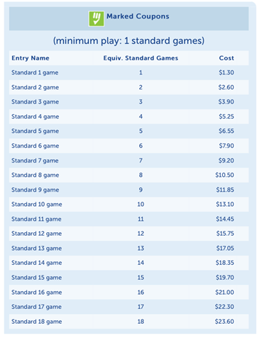

End of Application